AWS Cloud Practitioner 2022: Technical Essentials Part 1
The AWS Cloud Practitioner exam validates a candidate’s ability to define basic cloud infrastructure and architectural concepts, and important services on the AWS platform. You should also be able to explain basic security and compliance aspects of AWS cloud services. AWS Technical Essentials is an AWS course that introduces you to fundamentals of AWS compute and networking services, including the shared responsibility model and AWS security triad, the Amazon Elastic Compute Cloud (EC2), and routing and security using the Amazon Virtual Private Cloud (VPC). This course is one of a collection that prepares learners for the AWS Certified Cloud Practitioner 2022 certification.
Table of Contents
1. Video: Course Overview (it_clawsp22_01_enus_01)
2. Video: Amazon Web Services (AWS) (it_clawsp22_01_enus_02)
3. Video: The AWS Security Triad (it_clawsp22_01_enus_03)
4. Video: Compute as a Service in AWS (it_clawsp22_01_enus_04)
5. Video: Using Amazon Elastic Compute Cloud (EC2) (it_clawsp22_01_enus_05)
6. Video: Server-based vs. Serverless (it_clawsp22_01_enus_06)
7. Video: Using Amazon Virtual Private Cloud (VPC) (it_clawsp22_01_enus_07)
8. Video: Amazon VPC routing (it_clawsp22_01_enus_08)
9. Video: Amazon VPC security (it_clawsp22_01_enus_09)
10. Video: Course Summary (it_clawsp22_01_enus_10)
1. Video: Course Overview (it_clawsp22_01_enus_01)
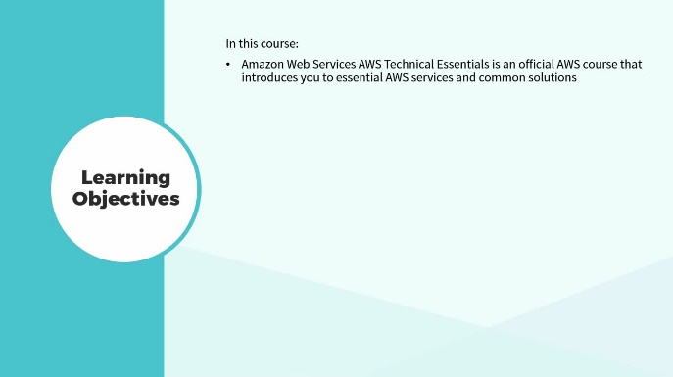
In this video, discover the key concepts covered in this course.
- discover the key concepts covered in this course
[Video description begins] Topic title: Course Overview. [Video description ends]
Amazon Web Services AWS Technical Essentials is an official AWS course that introduces you to essential AWS services and common solutions. [Video description begins] Your host for this session is Michael J. Shannon. [Video description ends]
The course covers the concepts necessary to increase your understanding of AWS services, so that you can make informed decisions about solutions that meet business requirements. This course one provides an introduction to Amazon Web Services along with the fundamentals of AWS networking and compute services.
2. Video: Amazon Web Services (AWS) (it_clawsp22_01_enus_02)
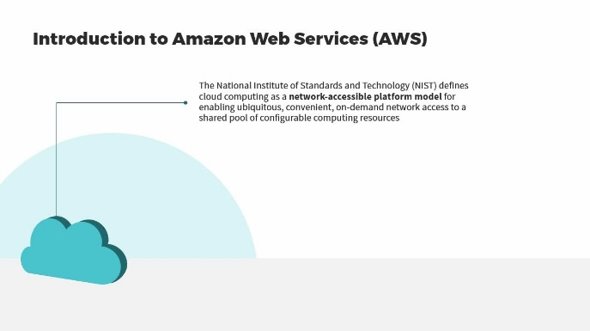
Upon completion of this video, you will be able to recall key service offerings of Amazon Web Services (AWS).
- recall key service offerings of Amazon Web Services (AWS)
[Video description begins] Topic title: Amazon Web Services (AWS). Your host for this session is Michael J. Shannon. [Video description ends]
The National Institute of Standards and Technology, NIST, defines cloud computing as a network-accessible platform model for enabling ubiquitous, convenient, on-demand network access to a shared pool of configurable computing resources. Let's break this sentence down. Ubiquitous means AWS can be accessed in regions all over the world, on every continent, with a wide variety of devices.
It's convenient and on-demand. That's a user-friendly online portal, and a shared pool of configurable resources is built upon Type 1 hypervisor or virtualization technology. We're virtualizing resources like networks, servers, storage, applications and services, and data centers all over the world, and can be rapidly provisioned and released with minimal management effort or interaction from the service provider itself.
In fact, many individuals and small businesses can work in Amazon Web Services and actually never interface with a real human being. Cloud computing data centers leverage clusters of virtual machine managers, hypervisors, to deliver multi-tenancy solutions to customers in regions all over the world. Advantages of cloud computing are that there's no need for customers to make large upfront investments, for example, in server farms and data centers.
You can provision just the right amount of resources using powerful tools at Amazon Web Services. Customers no longer need to spend time managing hardware and cabling, racks of servers and infrastructure devices, costly server farms and data centers. And consumers can provision or de-provision the exact resources necessary when needed, as needed, with a Pay-As-You-Go, Pay-As-You-Use model. AWS is the leader. Gartner's 2021 evaluation of cloud infrastructure and platform services placed AWS highest in the ability to execute and completeness of vision categories. International Data Corporation (IDC) listed AWS and Microsoft Azure as the top cloud service providers of 2021.
Let's take a quick survey of the different offerings at Amazon Web Services. In alphabetical order, we have archiving, reasonably priced solutions for data archiving up to petabyte scale. Backup and restore, durable and cost-effective choices for backups and disaster recovery. In fact, AWS has a managed service called CloudEndure for disaster recovery. Blockchain, shared ledgers for trusted connections between multiple entities.
Business applications, simplified management and lower-cost business applications. Cloud migration, fluid and simplified migration of applications and data to Amazon Web Services. And containers, fully managed services for application workloads using Docker and Kubernetes for orchestration. Content delivery, low latency and cached delivery of web sites, APIs, and video content to edge locations all over the world. Database migrations, time and cost-effective migration to managed and fully managed databases, such as AWS Aurora.
Data lakes and analytics, secure, scalable and cost-effective services for data lakes and analytics, with services such as AWS Redshift. DevOps, rapid and consistent build and delivery solutions using DevOps practices. E-commerce, highly scalable and secure offerings for online sales and retail businesses. And high-performance computing, HPC, superior networking and cloud-sized clusters for multifaceted challenges. Hybrid cloud architectures, extend the on-premise IT infrastructure to the AWS Cloud.
Internet of Things, IoT, scale to billions of devices and messages with cutting-edge solutions. Machine learning, leverage wide-ranging machine learning framework support. Mobile services, enable mobile application development at scale. And modern application development, produce and advance applications through rapid innovation lifecycles such as Agile, Spiral and CI/CD.
Remote work and learning, modern solutions for remote workers, students, and call center and service desk agents. Scientific computing, perform analysis, object storage and distribution of enormous data sets. Serverless computing, build and run applications without needing underlying servers. And web sites, use dependable, highly scalable and affordable web application tools such as Elastic Beanstalk and AWS Lightsail.
3. Video: The AWS Security Triad (it_clawsp22_01_enus_03)
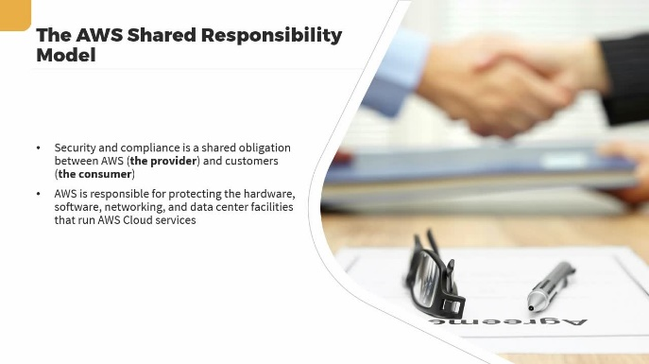
Upon completion of this video, you will be able to describe the shared responsibility model and the AWS security triad.
- describe the shared responsibility model and the AWS security triad
[Video description begins] Topic title: The AWS Security Triad. Your host for this session is Michael J. Shannon. [Video description ends]
When you're the customer of a cloud provider such as Amazon Web Services, you're co-creating value together. In addition, there's a shared responsibility. Security and compliance is a shared obligation between AWS, the provider, and the customers or the consumers of the services. AWS is responsible for protecting the hardware, software, networking and data center facilities that run AWS Cloud services.
In fact, AWS goes to great lengths to choose just the right location for their data centers and they're placed in availability zones that are tens of miles apart for disaster recovery purposes. Customer responsibilities are based on the services they select, which further determines the amount of configuration that they must do for security. Here we see the AWS Shared Responsibility Model for Infrastructure as a Service, and there's a clear demarcation between AWS who has responsibility for security of the cloud, and we, the customer, who has responsibility for security in the cloud.
AWS has their regions all over the world. In those regions they have at least three availability zones that are tens of miles apart or more, and then in metropolitan areas all over the world, they have edge locations. That supports the content distribution networking, for example, with AWS CloudFront. In addition to their hardware and global infrastructure in data centers all over the world they provide four core services: compute, storage, database and networking.
Above that, are the customer responsibilities. With Infrastructure as a Service, the customer chooses to do client-side encryption, data integrity authentication, or to choose server-side encryption based on the service or the Key Management Service, KMS, as well as protecting network traffic. They also choose the operating system, network design and firewall configuration, as well as platform, applications and data. They're also responsible for their own Identity and Access Management or identity management, to the IAM service or using single sign-on federated services from their own identity provider.
AWS also has a security triad. The first part of the triad is Identity and Access Management. As a provider at the data center, AWS has strict Identity and Access Management with least-privilege principle, separation of duties and biometric multi-factor authentication. The second part is infrastructure security, specifically securing your virtual private cloud and the connectivity to that private cloud, or your virtual network. And then third, is Key Management Service or KMS. With Identity and Access Management, customers gain fine-grained access control across all AWS services.
Enterprises can designate who can conditionally access services and resources. IAM policies are deployed to enforce least-privilege permissions for workforce and systems. AWS recommends using the AWS Single Sign-On, SSO, to administer access permissions to AWS accounts, as a best practice. With infrastructure security, customers benefit from a data center and network architecture designed to satisfy the requirements of the most security-sensitive consumer. Early decisions involve Amazon Virtual Private Cloud, VPC, and subnet design, peering relationships, deploying Internet and Virtual Private VPN gateways, secure endpoint implementation, and various firewalls at OSI layers 3 through 7.
Those include network access control lists, NACLs, security groups and web application firewalls. With Key Management Service, you can simplify the generation and management of symmetric and asymmetric cryptographic keys over a wide array of services and applications. KMS is a secure and resilient service that utilizes hardware security modules, HSMs, to safeguard customer keys. It's incorporated with AWS CloudTrail monitoring to offer logs of all key usage to help meet regulatory and compliance mandates.
4. Video: Compute as a Service in AWS (it_clawsp22_01_enus_04)
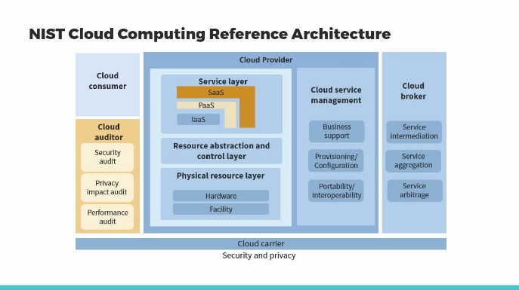
In this video, find out how to define "compute as a service" in AWS.
- define compute as a service in AWS
[Video description begins] Topic title: Compute as a Service in AWS. Your host for this session is Michael J. Shannon. [Video description ends]
Here's a diagram you're going to want to reference all throughout this training, the upcoming courses. This is the cloud computing reference architecture, and this is from NIST, the National Institute of Standards and Technology. We can see several players here in the cloud carrier world. First, we have the cloud consumer in the upper left-hand corner. We've talked about that.
That's the cloud customer, most likely being us, the customer of the cloud provider. The cloud provider is going to offer different service types. We have mentioned Infrastructure as a Service, IaaS, but there's also Platform as a Service, PaaS, which is usually semi managed or fully managed database services and DevOps services, and then Software as a Service, a wide variety of things like customer relationship management, enterprise resource planning, marketing, taxation services, cloud storage, payroll services, cloud-based service desk or call centers, all running on a physical resource layer of hardware and facility in data centers, in availability zones, in regions all over the world.
Cloud providers also have cloud service management, business support, provisioning, onboarding and offboarding, configuration, portability services and interoperability, for example, with a hybrid cloud. Other players include cloud auditors. They do security auditing, privacy impact auditing and performance auditing. And then cloud brokers. These are also referred to as MSSPs,
Managed Security Service Providers, or CASBs, cloud access security brokers, to provide intermediation, aggregation and arbitrage, for example, helping with single sign-on and federated activities or data loss prevention. A primary core service of all cloud service providers, including Amazon Web Services, is compute or Compute as a Service. Compute denotes events, applications and/or workloads that need more processing resources than memory or input/output resource requirements. Compute is typically used to describe concepts and objects that focus on computation and processing.
Cloud service providers like AWS offer a variety of server-based and serverless compute services. Let's compare some of the AWS compute services. There's AWS Elastic Compute Cloud or EC2, providing secure and resizable compute capacity, or virtual servers, in the cloud. Amazon EC2 Spot Instances. Here you can run fault-tolerant workloads for up to 90% off. It's a spot market similar to the silver or gold market, getting a good deal when there's excess compute resources available. Amazon EC2 Auto Scaling.
Auto scaling allows for automatic provisioning and deprovisioning of compute capacity to meet changes in demand. For example, spinning up frontend web servers. Amazon Lightsail. This is an easy-to-use cloud platform that offers everything necessary to build an application or website and you pay for it on a monthly basis. AWS Batch, fully managed batch processing at any scale. Amazon Elastic Container Service or ECS, a highly secure, reliable and scalable way to run containers. There's Amazon ECS Anywhere, running containers on customer-managed infrastructures.
And Amazon Elastic Container Registry, ECR, easily storing, managing and deploying container images. There's Amazon Elastic Kubernetes Service or EKS, a fully managed container orchestration service. Amazon EKS Anywhere, creating an operating Kubernetes clusters, on your own infrastructure. And AWS Fargate, a serverless compute engine for containers in the cloud. And AWS App Runner, where you can build and run containerized applications on a fully managed service.
AWS Lambda, run code without thinking about servers and you're only charged for the compute time you consume. We refer to this as Functions as a Service. AWS Outposts, running AWS infrastructure and services on-premises for a truly consistent hybrid experience, for example, bursting up to the cloud during peak online retail seasons. The AWS Snow Family will collect and process data in rugged or disconnected edge environments, sending and receiving data out of band in highly secure boxes or a shipping container. AWS Wavelength, delivering ultra-low latency applications for 5G devices.
VMware Cloud on AWS, a preferred service for all vSphere workloads to rapidly extend and migrate to the cloud. AWS Local Zones, running latency-sensitive applications closer to end users. AWS Savings Plan, a flexible pricing model that provides savings of up to 72% on compute usage. And AWS Compute Optimizer, recommending optimal compute resources for your workloads to reduce costs and improve performance.
There is AWS Elastic Beanstalk, an easy-to-use service for deploying and scaling web applications and services. EC2 Image Builder builds and maintains secure Linux or Windows Server images. Elastic Load Balancing, ELB, automatically distributes incoming application traffic across multiple targets. There's Application Load Balancers, Network Load Balancers and Gateway Load Balancers.
5. Video: Using Amazon Elastic Compute Cloud (EC2) (it_clawsp22_01_enus_05)
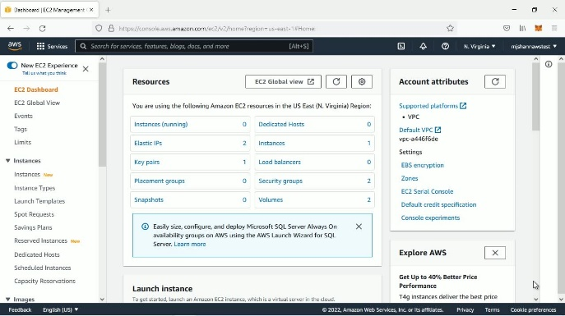
After completing this video, you will be able to describe the Amazon Elastic Compute Cloud service.
- describe the Amazon Elastic Compute Cloud (EC2) service
[Video description begins] Topic title: Using Amazon Elastic Compute Cloud (EC2). Your host for this session is Michael J. Shannon. [Video description ends]
In this demo, we're going to explore Amazon Elastic Compute Cloud or Amazon EC2. Compared to other providers like Azure, Google Cloud Platform and IBM, AWS offers the broadest and the deepest compute platform. They have over 500 instances available and the latest processors, operating systems and purchase models to assist you in meeting pretty much any workload. They support Intel, AMD and ARM processors, and as we're going to see here in a moment, they're the only cloud provider with on-demand Mac instances and 400 gigabit per second Ethernet networking.
If we scroll down here on the EC2 Dashboard, we can go here and we can launch an instance. Now typically what you would do, is you would create a golden image and launch the instance from a template. That way you don't have to walk through this process over and over and over, but we're going to come and take a look at some of the offerings here under launch an instance. Now, notice that we're choosing an Amazon Machine Image or an AMI.
So this is a template and it has all the configuration information necessary: the operating system, the root volume and optionally any application server and/or applications that you need to launch the instance. So we could call this instantiating an AMI, or sometimes we use the term spin up. As we scroll down here, notice you could have your own AMIs that you create and deploy. There's a community of AMIs, with a wide variety of different Linux builds and operating systems on different architectures.
There's a marketplace you can go to with AWS partners, but let's go back up here to the Quick Start and see some of our options. Right off the bat, we'll see a couple of Amazon Linux instances and these are actually their own Ubuntu builds. These are also eligible for the Free tier. What that means is, for example, if you choose either Intel or ARM, you'll have some different families that are eligible for the Free tier. So for example, the t2.micro instance, for the first 12 months following your sign-up you get up to 750 hours each month.
After that, you have Pay-As-You-Go. Let's go back. If we scroll down, we'll see there's three macOS builds. That's also special to AWS. We have Red Hat Enterprise Linux 8, SUSE, Ubuntu Server, we've got several different Microsoft options, a Debian option, Deep Learning Ubuntu, here's Microsoft Windows Server 2019 with Containers, here's 2019 with SQL Server 2017 Standard or Enterprise. Now, realize anything you do here that you deploy is going to be Infrastructure as a Service, IaaS. So whatever you deploy, you're responsible for the operating system, for the applications, for the containers, for SQL Server.
Everything running on that instance or instances. And when you do that, you're going to pick a network, a virtual private cloud, and a subnet to deploy these particular instances into. Notice, however, that if you don't want to go with Infrastructure as a Service, you could do Platform as a Service, and if you scroll back up it'll ask you, hey, are you launching a relational database instance, for example, MySQL or SQL Server?
If you are, you can choose the Amazon RDS, Relational Database Service, and that's going to be Platform as a Service. Now in this demo, we're just going to get our feet wet looking at the different aspects of EC2. Later on in this training we'll actually go deeper and we'll look at the configuration of an Amazon Machine Image, which involves choosing your AMI, choosing your instance type, configuring the instance, adding storage; which is going to be block storage, labeling it with tags, configuring your security group firewall and then going through a Review process before you actually deploy the instance.
6. Video: Server-based vs. Serverless (it_clawsp22_01_enus_06)
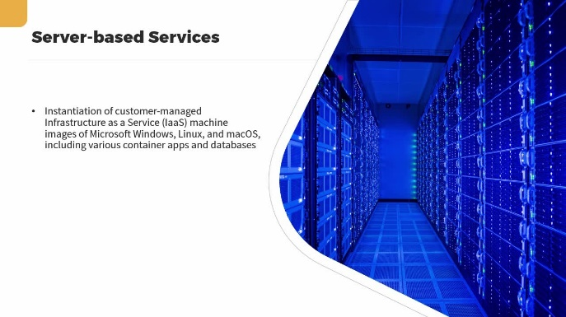
In this video, you will learn how to compare server-based instances and containers to serverless Lambda functions and Fargate containers.
- compare server-based instances and containers to serverless Lambda functions and Fargate containers
[Video description begins] Topic title: Server-based vs. Serverless. Your host for this session is Michael J. Shannon. [Video description ends]
In this brief lesson, we're going to compare server-based compute services to serverless compute services. Server-based services involve the instantiation of customer-managed Infrastructure as a Service, IaaS, machine images of Microsoft Windows, Linux and macOS, including various container apps and database services and other applications. Managed and fully managed servers are offered, where the provider maintains the underlying server architecture within hypervisors in data centers.
Server-based services support several Linux and Windows Server versions and three versions of macOS. Serverless services allows the customer to move more responsibility while enhancing the agility and innovation of applications. This is also known as Function as a Service, FaaS, when running serverless code in a wide variety of use cases. It enables the customer to run container applications and services without having to consider underlying servers.
It eliminates infrastructure duties such as provisioning, patching, maintenance and capacity management. A popular AWS serverless technology is AWS Lambda. Lambda enables the event-driven running of code for practically any application or backend service, without provisioning or managing underlying servers for Linux or Windows. It can be manually launched or automatically triggered from over 200 AWS services and Software as a Service, SaaS, applications, with a pay-as-you-use pricing model.
In this diagram we see a sample Python 3 function from AWS Lambda. [Video description begins] On screen it reads: from__future__ import print_function #import json import base64 def lambda_handler(event, context): for record in event['Records']: #Kinesis data is base64 encoded so decode here payload=base64.b64decode(record["kinesis"] ["data"]) print("Decoded payload: " + str(payload)). [Video description ends] AWS Fargate is a serverless, pay-as-you-go compute engine for building applications without managing servers, that's compatible with both Amazon ECS, Elastic Container Service and Amazon EKS, Elastic Kubernetes Service. You basically build the container image, define your memory and compute resources necessary, run and manage the applications, and then pay for requested compute resources when used. And the application isolation is by design.
7. Video: Using Amazon Virtual Private Cloud (VPC) (it_clawsp22_01_enus_07)
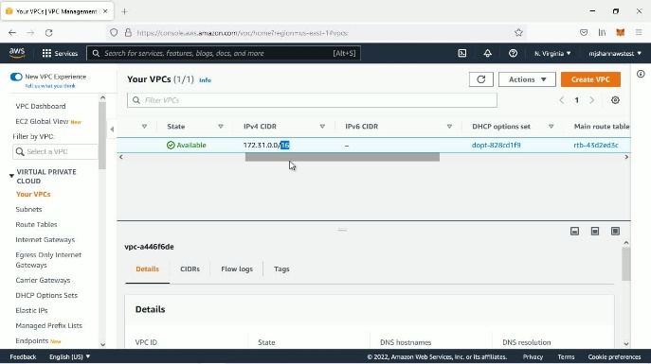
After completing this video, you will be able to describe the components of Amazon Virtual Private Cloud (VPC).
- describe the Amazon Virtual Private Cloud (VPC) components
[Video description begins] Topic title: Using Amazon Virtual Private Cloud (VPC). Your host for this session is Michael J. Shannon. [Video description ends]
In this demo, we're going to look at the AWS version of a virtual network, called the VPC, the Virtual Private Cloud. And we're at the VPC Dashboard up in my account, and we can see that we have the ability to actually Launch EC2 Instances from the VPC Dashboard. And of course, if we do that, we're going to launch an instance into a subnet or Subnets into our Virtual Private Cloud or our virtual network.
I'm going to click on Your VPCs and what we notice, I'm going to have a single VPC, it's got an identifier, vpc-whatever. [Video description begins] VPC ID reads vpc-a446f6de. [Video description ends] We scroll down, we can see it's Available. All of your virtual networks at AWS are going to be a /16 CIDR or CIDR network. So, a CIDR stands for Classless Inter-Domain Routing. You may pronounce it CIDR or CIDR, I'm here in Texas, I pronounce it CIDR, and you can see that my network is 172.31/16.
And so I'm going to deploy Subnets into this network. Now, one question that comes up sometimes is, can I just have one large subnet that takes up the entire 172.31.0.0/16 network? Yes, you could do that, but it's pretty rare. Usually you're going to deploy subnets, there's going to be some subnet of this network, usually a /20, which gives you about 4090-something hosts, or a /24 that gives you 251 hosts, or sometimes you'll see a /30, for example, on a site-to-site VPN that only needs two addresses.
If I go down here, I see that my VPC does have a Main route table, [Video description begins] Main route table reads rtb-43d2ed3c. [Video description ends] has an identifier. We'll also see that this is the Default VPC. So it says Default VPC, Yes. So you're going to have in your account a Default VPC and you can have up to five VPCs per account. So I could have one Default VPC and four what we would call non-default VPCs. OK. So how do I create a non-default VPC in addition to this virtual network?
Well, several ways to do this. I can go up here, I can say create a VPC and that would create another Virtual Private Cloud, a second one in this account, by the way, in the North Virginia region, as you can see here. Another option is go back to the dashboard and launch the VPC Wizard, and this is going to give me a way to kind of do Infrastructure as Code light.
OK? So I can go through and kind of walk through a wizard to create a VPC. Do I want a VPC only, or do I want a VPC with subnets? What type of IPv4 CIDR block do I want? It'll be a /16 by default. How many Availability Zones? Do I want to provision these subnets? They're going to recommend at least 2.
And then how many public subnets do I want? How many private subnets do I want? [Video description begins] They're both set to 2 by default. [Video description ends] Now, if I go back up here and go back to Your VPCs, if we go to Subnets, we'll notice that this default VPC right here, ending in 6de, it actually has six Subnets. In fact, notice that all of these six Subnets here are in this 6de VPC. Right? Six of them. In the default, now, you might ask, why do I have six Subnets? Well, here's why.
I'm in the North Virginia region, and the North Virginia region has six availability zones. And because of that, when I create a default VPC in the North Virginia region in this account, they're going to go ahead and give me six Subnets, one for each availability zone. And you can see these are /20s so that means I have basically 2 to the 20th power hosts, which is 4096, but you never get all of those. OK? So I'm not going to get the 2 which represent the network itself and the broadcast, the directed broadcast, but I'm also going to lose other addresses as well.
For example, there's that default router that gets an IP address. There's a DNS service that gets an address and then some other that are reserved for the hypervisor, so I only get 4089 out of the 2 to the 12th power, 4096. And if you go to Route Tables we'll notice that we have a route table right here, and this route table is being used, by the way, by my VPC, and if I were to look at the Routes in the route table, I would see two entries. So the first one is just the actual local network, which there's our local network for the VPC, 172.31.0.0/16, and then the entry next to that says, anything else or everything else goes to the Internet gateway.
So I have an Internet gateway entry into this route table. [Video description begins] It reads igw-03dc3b78. [Video description ends] So what that means is, any subnet that's using this route table, and by the way, all six of these Subnets are using this route table d3c. If I go up here to Subnets again and I look at these, it's going to tell me down here that I'm using the d3c Route table. So what that means is, these are public subnets because they have an Internet gateway in their Route table. So that is a Virtual Private Cloud. There's another way to create VPCs, and that would be to use the CloudFormation which is full on Infrastructure as Code.
So, Create and Manage Resources with Templates. You have these Stacks and you have a Designer which allows you to see it graphically in JSON or YAML format. So that's full blown terraforming of your Virtual Private Cloud environment. However, as you have already seen, we can use the VPC Wizard, which we showed you, or you can just simply go into the Your VPCs area and create a VPC by scratch, by clicking on the Create VPC button.
That's a quick overview of the Virtual Private Cloud in Amazon Web Services. This is where you're going to deploy not only your Linux and Windows and macOS EC2 instances, but you'll also deploy virtual appliances like virtual routers, virtual firewalls and other Software as a Service or marketplace solutions that you use at Amazon Web Services.
8. Video: Amazon VPC routing (it_clawsp22_01_enus_08)
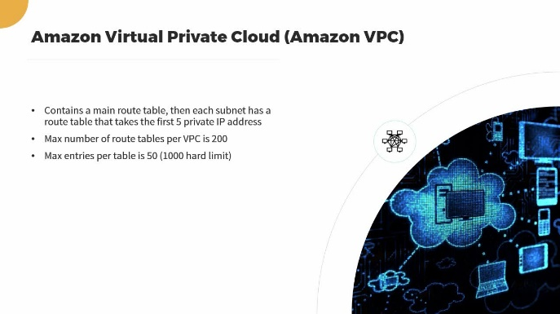
In this video, you will learn how to define routing in a VPC.
- define routing in a VPC
[Video description begins] Topic title: Amazon VPC routing. Your host for this session is Michael J. Shannon. [Video description ends]
In the previous lesson, we got a demonstration of the VPC or the Amazon Virtual Private Cloud. Let's review some of the distinctives. The VPC contains a main route table, then each subnet has a route table that takes the first 5 private IP addresses. The max number of route tables per VPC is 200. The max entries per table is 50, even though there's a hard limit of 1000.
So if you're a special large customer of Amazon Web Services, you can request a hard limit. So in AWS you have quotas or limits, then you have hard limits which can be used by large customers. An Internet gateway, the IGW, is a logical connection between the Amazon VPC and the global Internet, the public Internet, that gets placed into a subnet route table to make it a public subnet. And we saw that in the previous demonstration.
All six of those subnets in my default VPC were public because they were using a route table that had an IGW entry in it. A virtual private gateway in the route table would make it a VPN-only subnet. In other words, the other side of a site-to-site VPN. The route table can also have entries for gateway endpoints to the S3 service, and the DynamoDB service. The route table could also have entries to NAT gateways for instances in private subnet. Take a look at this diagram. Remember that each VPC by default is a /16 network.
For example, this could be the 10.0.0.0/16 network. Each subnet has a route table, and realize that both of these subnets could use the same route table as we saw on the previous demonstration, or each subnet could have its own route table. The route table will have entries to either the IGW which makes it a public subnet, or if the route table has an entry to a VPG, a virtual private gateway, it'll be a VPN-only subnet.
If the subnet does not have an entry to an IGW or a VPG, it's a private subnet. The VPC router seen at the top is part of the AWS Cloud and by default there's a DNS service that's activated for the VPC that'll actually take up one of those private addresses in each subnet. Something else that could be in the route table, let's say, for subnet 1, is a NAT gateway.
Let's say that the instances in subnet 2 on the right are backend database servers that are being used by frontend web servers in subnet 1. If those private database servers wanted to get to the Internet, let's say to get Windows Update services, what you would do is you would deploy a NAT gateway in subnet 1. That NAT gateway would use an elastic IP address, an IPv4 address, a public address, and then you would put that NAT gateway entry into the route table that's being used by subnet 2.
That way the instances, if they want to go to Windows Update service, can basically go to the NAT gateway in subnet 1 and go out to the Internet and get their service pack or their update. However, nobody on the Internet can create a connection through the IGW to that NAT gateway. We'll learn more about VPC routing in an upcoming course. [Video description begins] A diagram displays on screen. At the bottom of the diagram, under Subset 1, it reads: 10.0.0.0/24, 2001:db8:1234:1a00::64. Under Subset 2, it reads: 10.0.1.0/24, 2001:db8:1234:1a01::64. [Video description ends]
9. Video: Amazon VPC security (it_clawsp22_01_enus_09)
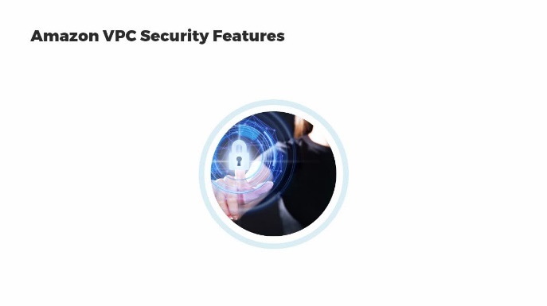
Find out how to outline the Amazon VPC security features.
- outline Amazon VPC security features
[Video description begins] Topic title: Amazon VPC security. Your host for this session is Michael J. Shannon. [Video description ends]
In this lesson, we're going to get a brief introduction to the security features of the Amazon Virtual Private Cloud. Later on in this training, in an upcoming course, we'll go much deeper into AWS security. As we saw in the previous lesson, your first security feature of the Virtual Private Cloud is how you design your subnets.
Are your subnets going to have entries to Internet gateways to make them public? Are they going to have entries to virtual private gateways to make them VPN-only? Or are they going to have neither one of those gateways and be a private subnet? The routing tables can also have endpoint gateways and NAT gateways to name a few. You'll also configure your network access control list, layer 3 and layer 4, stateless or static firewalls, which permits or denies inbound and outbound traffic to each subnet, affecting all of the instances in each subnet.
Each instance also has a security group firewall, a stateful firewall at the hypervisor level that by default is attached to the elastic network interface, which is by default Ethernet0 on the instance. You can also have a managed site-to-site VPN from your virtual private gateway to a wide variety of options, getting 1.25 gigabit per second IPsec IKEv1 or IKEv2 tunnels. You can also have secure VPC endpoints to hundreds of services in Amazon Web Services, bypassing the Internet altogether, not needing a public IP address, but connecting directly through an API call to the service.
For example S3, DynamoDB, or the elastic file system, CloudTrail or CloudWatch. You can also have peering connections between your VPCs as well. Every account in good standing has the anti-denial-of-service, an anti-DDoS feature, referred to as AWS Shield Standard, that's going to protect you from common denial-of-service attacks. If you have a business support plan or an enterprise support plan at AWS, you can pay extra to get AWS Shield Advanced, which includes the Web Application Firewall or the WAF.
10. Video: Course Summary (it_clawsp22_01_enus_10)
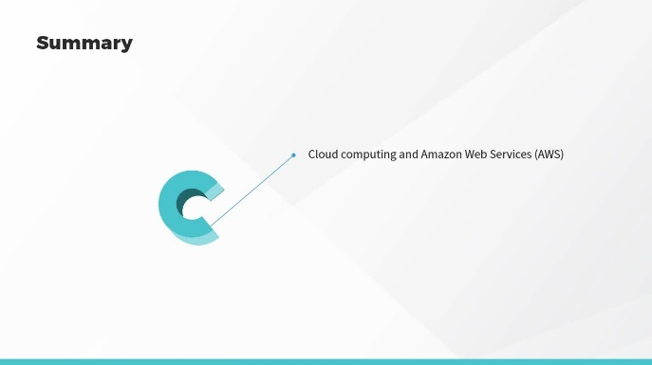
In this video, we will summarize the key concepts covered in this course.
- summarize the key concepts covered in this course
[Video description begins] Topic title: Course Summary. [Video description ends]
In this lesson, we covered cloud computing fundamentals and an introduction to Amazon Web Services, AWS. We explored the AWS Shared Responsibility Model and the security triad. We defined AWS compute services.
We learned about Amazon Virtual Private Cloud, VPC, VPC routing, and the basics of VPC security. Coming up in the next course, we'll look at additional AWS services and common solutions.
© 2025 Skillsoft Ireland Limited - All rights reserved.

